**Week 13**

Nothing too much happened this week as we all had a lot to do on the side of this project but we are off to a decent start. On wednesday we had the TA-session and the main thing was to introduce our process to the supervisor. We showed our process and everything was going in the right direction. Supervisor gave few remarks to think about in our design of the pyramid box:

* Size of the box - does everything fit in?

Currently it seems like the size of the box could do it but when we get the components and see how we assemble them, we have to measure if the size has to be changed in some way.

* Thickness of the top of the box - an axel of the servo is quite short and it has to be reached from the top of the box.

We have to think if we could make the top thick enough to be able to connect sensors to the axel or do we embed the servo in the top part of the box so we get it on the same level with the top of the box.

Here is the current design of the box by Aleksi: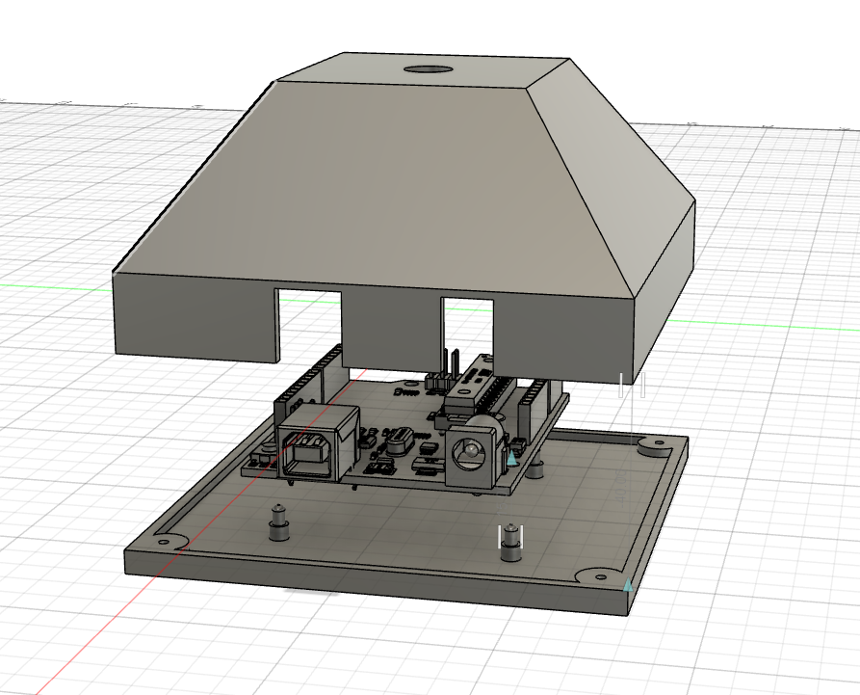

And here is the current design for sensor housing by Aleksi:

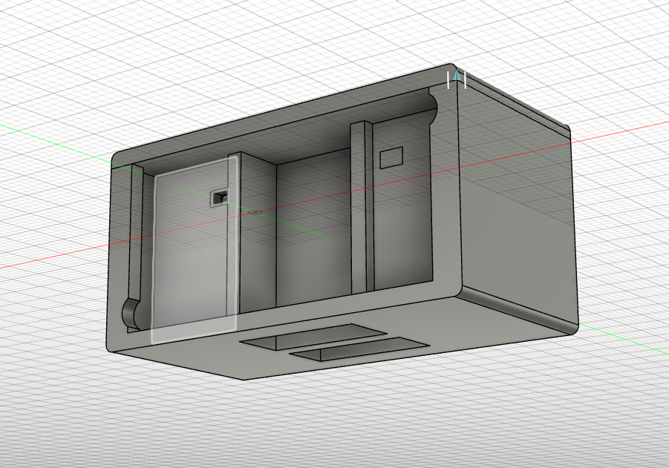

After the TA-session we discussed together what’s going on with the project and thought what could be done if there is spare time on the easter holidays:

* Writing the weekly report
* Maybe building Tinkercad circuit design further

Project team: Aleksanteri, Aleksi, Konsta and Kaarlo